Digital Assignment – II
BCSE307L – Compiler Design
Both Slots : C1+TC1 & C2+TC2
Class: VL2024250101542, 1546

- The grammar given below is used to parse all possible expressions in C that involve(only) variables of pointer datatype (ignoring the semi-colon).

Expression→ expression + Terminal/ Terminal
Terminal → Terminal * Factor / Factor
Factor → identifier | (expression)

Prove the above grammar is SLRand not LALR. Also parse the string “identifier+identifier*identifier”.

- Parse the following grammar using CLR parsing
SoftwareComputing Computing
Computing complex Computing | default. Parse the string “complex complex default”

- With the following production and semantic rules, draw dependency graph for the annotated parse tree 3*5

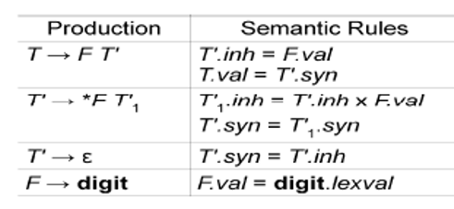

- Write the translation scheme and covert the 2+3*4 into postfix

- Construct syntax tree for X*Y-5+Z. Write semantic rules on your own

